OPEN DIGITAL RESOURCES IN EDUCATION & SCHOOL INNOVATION
Presenting ODS to the Teaching Community
A Workshop Seminar
Venue: Ellinogermaniki Agogi, Thursday June 20th
Greece 30/5/2013

Teachers of all subjects and levels, educational professionals, policy makers and repository contributors are cordially invited to attend the “Open Digital Resources in Education & School Innovation” workshop seminar, hosted by the Open Discovery Space European initiative. The event will take place in Ellinogermaniki Agogi in Attica Greece, on Thursday June 20th.

The use of online content and the relevant innovative teaching techniques are reshaping the modern school. Though extremely exciting, acquiring knowledge of such tools is not an easy task. The “Open Digital Resources in Education & School Innovation” workshop seminar aims at building the necessary structures and networks that will facilitate the introduction and embracing of e-learning by the teaching community.

Talks on a range of relevant issues, such as European E-Learning Policies, the role of e-learning in the Opening up Education agenda, the development of multilingual educational social media and what ODS can offer to a school, will be followed by presentations of innovative teaching practices, involving e-learning sources, as well as a two-hour workshop on how to use the available resources on ODS, how to create a school e-library on ODS and how to build an ODS community of teachers and schools.

For more information on the event, please contact Ms Eleni Chelioti at chelioti@ea.gr or Mr Stephanos Cherouvis at stecherouvis@ea.gr.

About ODS
Open Discovery Space is a European CIP PSP co-funded project which began in April 2012. It gathers 51 partners across 23 countries, led by the IT Solutions and Services expert group: INTRASOFT International (Luxembourg). For the full list of partners, please check our website.

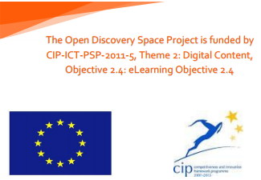
Contact our Coordinator: Nikolas Athanasiadis
Email: nikolas.athanasiadis@intrasoft-intl.com || Telephone: +35 4410122186
Info: www.opendiscoveryspace.eu || Like ODS FAN Page on Facebook || Follow ODS on Twitter

