12 June 2013

IRU salutes heroic Russian driver for saving two lives

Andrey Damirovich Dilmukhametov awarded IRU Grand Prix d’Honneur for heroically rescuing two injured people from burning van.
Amman – During the opening ceremony of the 7th IRU Euro-Asian Road Transport Conference, Ministerial Meeting and Co-ordination Meeting of International Organisations and Financial Institutions, IRU President, Janusz Lacny, today awarded Andrey Damirovich Dilmukhametov the IRU Grand Prix d’Honneur*, as an international recognition for the outstanding act of courage performed in the course of his duty, which saved two lives.
On 3 July 2012, Mr Dilmukhametov, a 42-year-old professional driver for the KAB transport company based in the Republic of Tatarstan, Russia - a member of IRU's Russian Member Association, the Association of International Road Carriers (ASMAP) - was driving his semi-trailer on an uphill section of road, when he braked due to an uneven road surface. Seconds later, he felt something crash into his truck and immediately jumped out to assess the situation. He saw that an LPG fueled van had crashed full-speed into his semitrailer and burst into flames.
Undeterred, Mr Dilmukhametov seized two fire extinguishers, put out the fire and heroically risked his own life to rescue the wounded driver and passenger from the van. Andrey’s valiant actions saved not only two lives, but the valuable cargo as well. His self-sacrifice was all the more admirable as the van – powered by a liquefied gas fuel system – could have exploded at any time. And yet, he made it his priority to rescue the injured and prevent a potentially devastating situation from becoming a human catastrophe.
When asked if he realised what risks he faced when rescuing the two van passengers, Mr Dilmukhametov answered, “I did what anyone would have done in my situation. I saw that the people in the van needed help, so I helped them”.
Presenting the award, IRU President, Mr Lacny, stated “The heroic actions of Mr Dilmukhametov instill a genuine sense of hope in humanity, that when you are in a frightening, life-threatening situation, there are normal, hard-working people ready to perform heroic acts and risk their lives to help others. Thanks to his training, instinct and rapid response, he saved two lives in an incredible act of courage and the IRU is proud to award this unsung hero the Grand Prix d’Honneur and count him among the ranks of our profession”.
* * *
Watch the opening ceremony tribute movie for Andrey Damirovich Dilmukhametov
Download high resolution photos from the award presentation
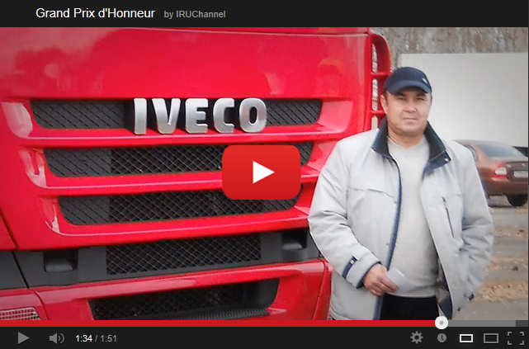

* The “Grand Prix d’Honneur” was created in 1967 as a distinction awarded by an international jury to a driver or drivers in international road transport, who perform an outstanding act of courage during their professional duties. See regulations.
The jury, which attributed the IRU Grand Prix d’Honneur 2012, was comprised of representatives from the Alliance Internationale de Tourisme & Fédération Internationale de l’Automobile (AIT-FIA), International Motorcycles Manufacturers Association (IMMA), International Road Federation (IRF) and the International Road Transport Union (IRU).

Press contact: Juliette Ebélé, +41 22 918 27 07, press@iru.org
Join the IRU community: | | | | |

