PRESS RELEASE PRESS RELEASE PRESS RELEASE PRESS RELEASE PRESS RELEASE

European Association Awards sees 17 organisations crowned as
the “Best of the Best”…
European Association Awards | www.europeanassociationawards.com
23rd February 2018 | Steigenberger Wiltcher’s Hotel, Brussels

Organisers GCN Events are delighted once again to congratulate all the winners of the 2nd annual European Association Awards.
The Gold prize-winners of the 17 categories are listed below, and full details of the bronze and silver winners can be found on the website : www.europeanassociationawards.com
Best Association Website: Union for International Cancer Control (UICC) – www.uicc.org
Best Association Magazine or Publication: MedTech Europe – MedTech Week Magazine (vol. 3)
Best Association Networking Event: European Aluminium – Driving Mobility to a Low Carbon Future
Best Association Conference (225+ Delegates): EDANA – OUTLOOK 2017
Best Association Conference (<225 Delegates): The Wine and Spirit Trade Association – WSTA Annual Conference 2017
Best Use of Social Media: EENA – Make EU safe
Best Membership Initiative by an Association: Liechtenstein Bankers Association (LBA) – Villa Wirbelwind
Best Communications Campaign Secretariat (<10): spiritsEUROPE – CETANOW
Best Communications Campaign Secretariat (10+): AEBIOM – The European Biomass Association – The European Bioenergy Day
Best Association Training Initiative: European Association of Communications Agencies – The EACA International Advertising Summer School
Best Association Partnership or Collaboration: Influenza Hub – ZN Consulting, Mylan, Sanofi Pasteur, IFPMA
Best Lobbying or Advocacy Campaign: European Chemical Industry Council (Cefic) – Safeguarding the competitiveness of European manufacturing industries
Best Provision of Industry Information SolarPower Europe – Global Market and Policy Data
and Intelligence:
Most Innovative Development by an Association: European Respiratory Society – Creation of the European Lung Foundation (ELF)
Association Leadership Award: Euroheat & Power – The Euroheat & Power Team
Best National Association: EEF, the manufacturers’ organisation
Overall Best European Association: AmCham EU

These awards are a celebration of the vital work that European Associations do on behalf of their members to ensure their voices are heard throughout Europe. They were announced at a ceremony attended by 250+ senior association executives representing a diverse cross-section of European industry and markets on 23 February at the Steigenberger Wiltcher’s Hotel in Brussels.

Claire Wormsley, Founder and Managing Director of GCN Events said:

“We were delighted once again to welcome so many European Associations and recognise the example of exceptional quality and excellence all our finalists set. It is important to celebrate these hard-won achievements and shine a spotlight on the incredible impact for change that associations and trade bodies have on their industry and to the benefit of society as a whole.”

The ceremony was enlivened by the talented Irish comedian Andrew Maxwell, provided courtesy of Kruger Cowne www.krugercowne.com

. 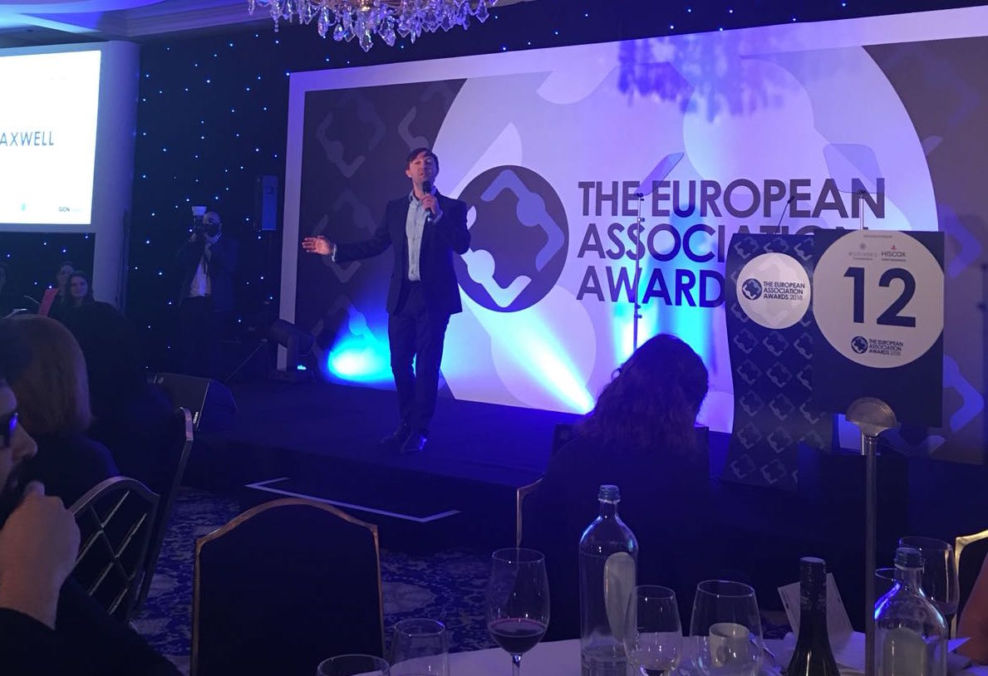
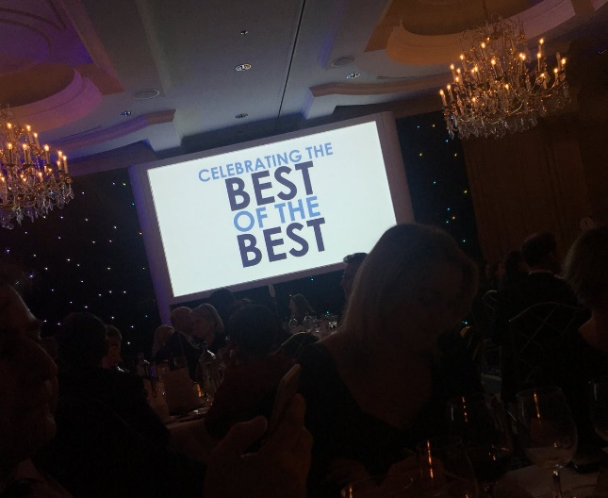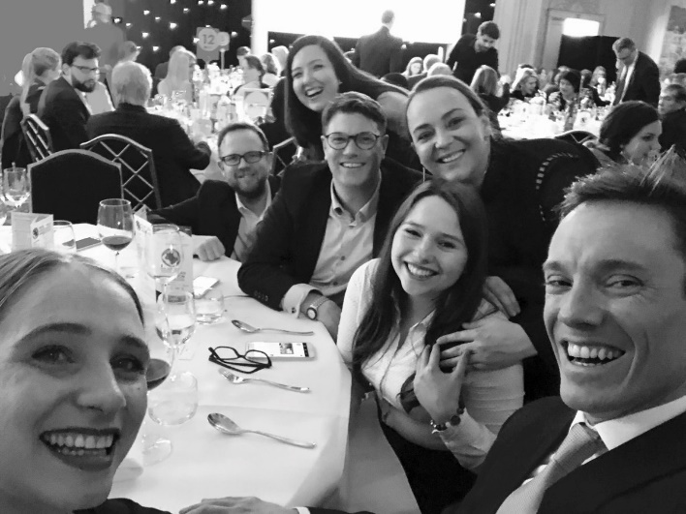

Further high-resolution images can be downloaded from our picture gallery : https://capturise.pixieset.com/eaa <tbc>
Next year’s ceremony will once again take place in February in Brussels.
European Association Awards 2018 Sponsors
Steigenberger Wiltcher’s Hotel : www.steigenberger.com
Hiscox Insurance : www.hiscox.co.uk/events
Edinburgh International Conference Centre : www.eicc.co.uk
London & Partners : http://conventionbureau.london/associations

Further information
Please contact Louisa Rogers louisa@globalconferencenetwork.co.uk or Michelle Coulsey michelle@globalconferencenetwork.co.uk.

About GCN Events
GCN Events provides quality information and events for the conference, association and venue sectors. We facilitate dialogue, best practice and strategic thinking through a variety of different forums and formats including awards, summits, education and industry wide projects.
http://globalconferencenetwork.co.uk/

