Press Contact
The European Plastic Pipes & Fittings Association
Claudia Topalli
Communications Manager
Phone +32 (2) 736 24 06
Claudia.topalli@teppfa.eu

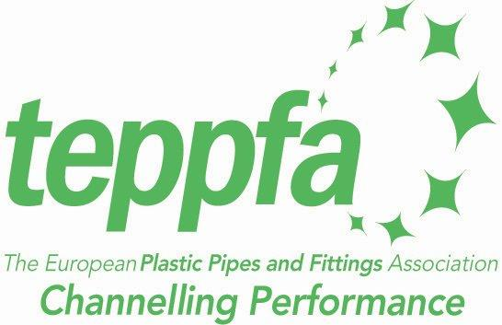

Press Release- TEPPFA
Brussels, 08-10-2013

DG Environment selects TEPPFA value chain partnership for PEF pilot
TEPPFA (The European Plastics Pipes and Fittings Association) is proud to announce that it has been selected by the European Commission to participate in the Product Environmental Footprint (PEF) pilot scheme which measures environmental performance throughout a products’ lifecycle. TEPPFA will lead the technical secretariat for one of the pilot scheme projects, supported by project partners Plastics Europe, EuPR, Vito and the PEX Association

Tony Calton, General Manager of TEPPFA, explained that the association has for several years been at the forefront of developing Life Cycle Analyses and Environmental Product Declarations for the plastic pipes industry and believes that this has contributed to their success with selection for the PEF pilot scheme.

This announcement is part of the EU Single Market for Green Products (SMGP) initiative - an EU initiative that seeks to harmonies the methodology to measure the environmental performance of products and organizations.

“To boost sustainable growth consumers need to be able to identify genuinely green products and companies, and this is an important step in that direction. And it's clear from the 90 applications we received that industry too is on board. I would like to thank all applicants for the excellent proposals – it was extremely hard to make a choice and I do realise that behind each proposal there was serious effort. I look forward to working closely with volunteers. Reliable and comparable information about the environmental impacts will bring increased transparency and will build trust with consumers, business partners", said European Commissioner for the Environment Dr Janez Potočnik.

