Ukrainian Foundation for Democracy «People First»
www.peoplefirst.org.ua

Working for maximum results
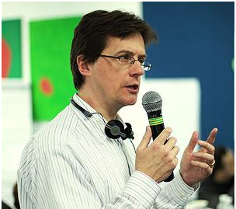
14/02/2013
On 11-14 February 2013 Ukrainian Foundation for Democracy «People First» jointly with the British charity INVOLVE with the support of Westminster Foundation for Democracy (UK) held a strategic workshop and training on methods of activation and engagement of citizens into public life. Simon Burall – Director of the organization, Ingrid Prikken – Project Manager in the field of public participation and Dr. Andy Williamson – Digital Engagement Associate have visited Ukraine.
For almost a decade INVOLVE works in the field of civil society development and has an extensive experience of coordination and cooperation with governments and organizations around the world. They came to Kyiv to share the experience, know-how and theoretical knowledge of international trends and developments in the field of civic participation.
The main topics of discussion were the question of motivation and incentives for civic activity in Ukraine, activation of communities to solve their own problems and issues at the national level.
«People First» Foundation team along with its partners from the regions of Ukraine has studied the underlying driving forces of social processes with broad public participation. Experts provided information on best practices, processes and examples of how to mobilize the public to implement both initiatives of governments and offers of ordinary citizens. Ukrainian party was extremely interested in adaptability of mentioned examples for use in the Ukrainian context.
During the event the parties exchanged views and experiences on a wide range of issues. In particular, Ukrainian and foreign experts discussed innovative and effective ways of combining on-line and off-line methods for enhancing civil society. This brought «People First» Foundation a step closer to achieving one of its key objectives – forming a community of people ready to participate in the national consultations on the reform of the Ukrainian democracy and creation of the «People’s Charter».
The seminar was visited by representatives of the Westminster Foundation for Democracy: newly appointed Director of Programmes Jamie Tronnes and Program Manager for Europe Alex Romaniuk. British guests noted the fervor of discussions with INVOLVE. They also confirmed their interest in further cooperation with «People First» Foundation.
Representatives of INVOLVE proposed to continue to share experiences, and promised to help «People First» Foundation remotely, providing practical advice and expertise on the most important events and documents of «People First» Foundation.
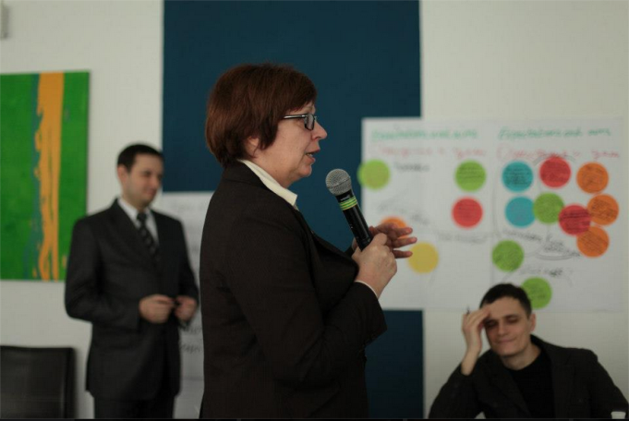
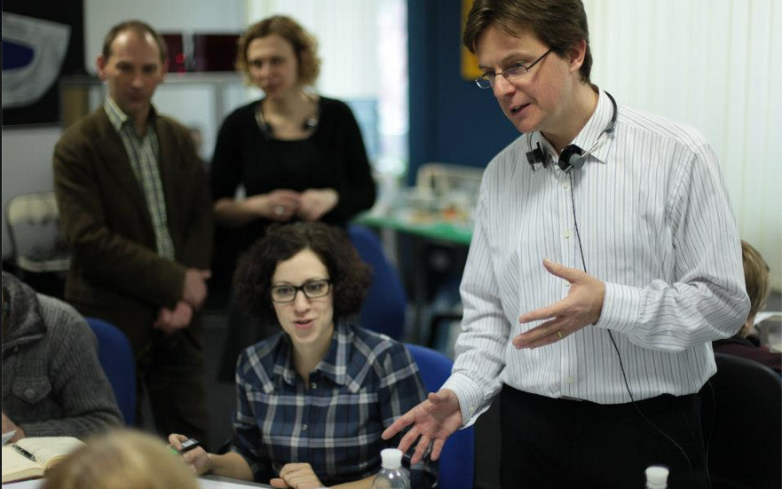
Ukrainian party, for its part, expressed appreciation for the pithiness and fullness of the event and invited British counterparts to verify in the near future the progress to be made towards civil society development and implementation of «People First» Foundation projects.

https://peoplefirst.org.ua/en/about-foundation/news-and-events/working-for-maximum-results

