Diverse and Affordable Parcel Delivery Services to Boost E-Commerce
PostEurop and 11 CEOs of European postal operators discuss e-commerce and parcel delivery with Vice-President Ansip

FOR IMMEDIATE RELEASE – Brussels, 19th October 2017
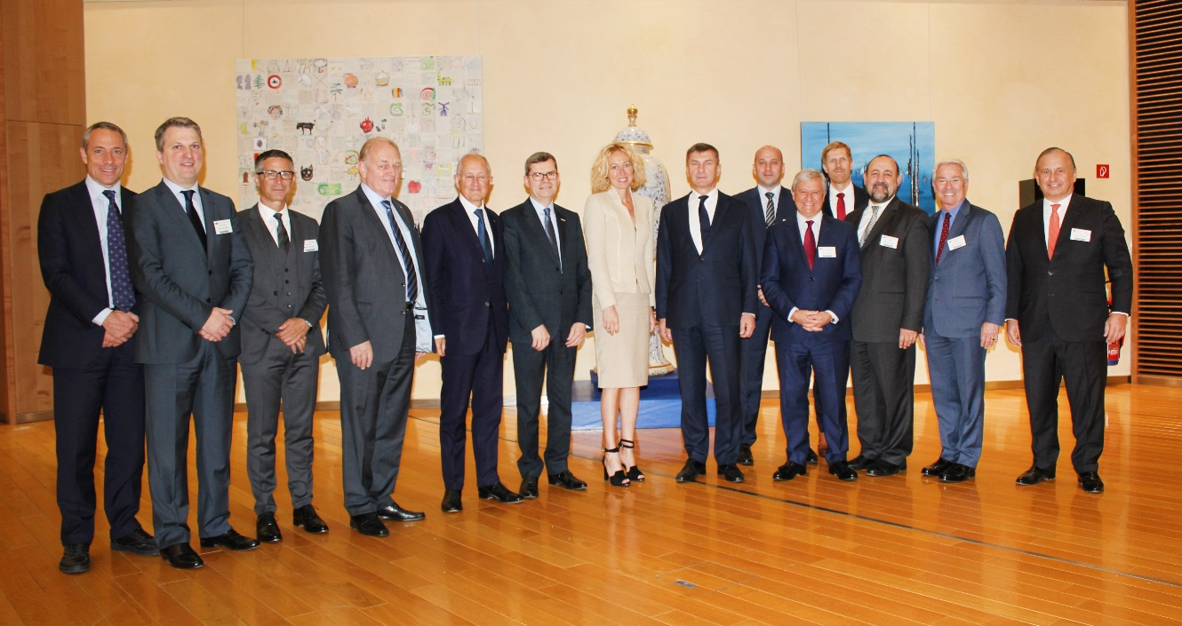
PostEurop and 11 CEOs of European national postal operators met with Andrus Ansip, Vice-President of the European Commission for the Digital Single Market. This was part of a regular dialogue between the European Commission and postal operators. The constructive discussion covered developments in the parcel delivery and e-commerce markets, and how the posts are introducing new products and services to meet consumers’ demands, as well as the proposed cross-border parcel delivery regulation.
European national postal operators showcased to VP Ansip innovation and investments made to match the needs of small and large e-retailers, and consumers for fast, traceable and efficient parcel delivery, domestic and cross-border.
After the meeting, Jean-Paul Forceville, Chairman of PostEurop commented:
“PostEurop’s commitments to enhancing interoperability and facilitating cross-border flows of parcels to meet consumers’ demands work all year round. Efficient and more convenient parcel delivery fuels the growth of e-commerce across Europe. Our sector is subject to strict regulatory scrutiny, over-regulation must be avoided.”
The 2017 edition of the Commission’s EU Consumer Conditions Scoreboard showed that the number of consumers reporting issues with cross-border delivery has declined significantly. This has contributed to a highly increased trust in e-commerce: nearly 60% of European consumers felt confident about purchasing online goods and services from traders in another EU country, a substantial rise of more than 20 percentage points since 2014.
Participants to the meeting with VP Ansip included: Mr Georg Pölzl, Österreichische Post AG – Austria; Mr Ivan Čulo, Hrvatska pošta d.d. – Croatia ; Mr Joona Saluveer, Omniva – Estonia; Mr Philippe Wahl, La Poste – France; Mr Ingimundur Sigurpalsson, Islandspóstur hf – Iceland; Mr Matteo Del Fante, Poste Italiane S.p.A. – Italy; Mr Joseph Gáfa, MaltaPost p.l.c. – Malta; Mrs Herna Verhagen, PostNL – Netherlands; Mr Francisco de Lacerda, CTT-Portugal Post – Portugal; Mr Boris Novak, Pošta Slovenije, d.o.o. – Slovenia; Mr Javier Cuesta Nuin, Correos y Telegrafos S.A. – Spain; Mr. Jean-Paul Forceville, Chairman of the PostEurop Management Board.

* * * ENDS * * *

Notes to editors

PostEurop is the trade association representing European national postal operators, which are either partially state-owned or used to be state-owned. It has 52 members in 49 countries.

European postal operators are present in all 28 EU Member States and in EEA countries. They serve 175,000 retail outlets, employ 2 million people, operate 600,000 access points and account for 1 percent of the EU’s entire GDP.

Parcel delivery is a cornerstone of the fast-growing e-commerce industry, domestically and cross-border, and a crucial pillar of the EU’s Digital Single Market. Postal operators connect SMEs and e-retailers with citizens across Europe – from London to Bucharest, from Lapland to the Greek islands.

Every year, e-retailers and customers deliver 4 billion parcels through the post to their customers, friends and families across Europe. This represents 11 million parcels a day, on average. Many more parcels are also delivered through the many alternative providers competing with postal operators.

For more information about how postal operators contribute to the growth of e-commerce in Europe, visit our website: www.Deliver4Europe.eu
We are also happy to engage with you on this topic on Twitter: @Deliver4Europe

Commission Press Release on 25/07/2017: http://europa.eu/rapid/press-release_IP-17-2109_en.htm
PostEurop industry figure, http://www.posteurop.org/aboutus

