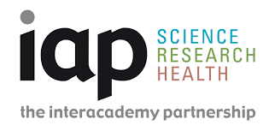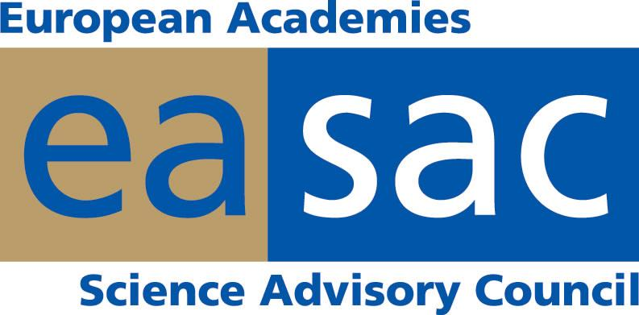
Volkswagen Foundation, IAP, and EASAC Press Release
Genome editing: Science, policy, and security experts call for proactive international dialogue about security — and benefits
19 October 2017
It will be vital to support and sustain a global culture of responsibility and integrity in research and innovation and to engage in an open dialogue with stakeholders.
From 11-13 October, over 100 scientific, policy, and security experts gathered in Hanover, Germany, at Herrenhausen Palace to assess the security implications of genome editing technology. This workshop began a dialogue amongst international experts about the benefits as well as potential for intentional misuse of genome editing technologies. Proactive international dialogue about genome editing and security is important because of the recent rapid development and widespread use of genome editing tools, in particular CRISPR Cas9, in countries that may have divergent regulations and research governance. The workshop recognised the importance of an open and inclusive dialogue with stakeholders as well as the promotion of a research culture that builds trust through responsibility and integrity.
The workshop reviewed the latest advances in genome editing and applications of potential societal value. These span medicine, plant and animal breeding, microbial production systems, and gene drives, systems that could potentially transform an entire population of select animal or plant species. In a series of plenary presentations and breakout groups on the potential security dimensions associated with the foreseen applications of the technology in human cell editing, agriculture, gene drives, and microbiology, experts expressed their views, and many called for the following points to be considered in future discussions on genome editing and security.
Scientific responsibility
Many workshop participants emphasised that it is vital to support and sustain a culture of responsibility and integrity in research and innovation and to engage with stakeholders. Moreover, researchers and policy makers must commit to continuing an open and inclusive dialogue that builds trust. As with other new and emerging technologies, a lack of communication about any uncertainties may undermine public confidence in science. Scientists and security experts should listen to concerns or fears regarding the misuse of genome editing, and provide their expertise on what is and is not likely. In addition, the scientific community must ensure that younger researchers and researchers from the global south have a voice in this on-going dialogue.
"The scientific community has a responsibility to take into account the reasonably foreseeable consequences of our activities and to engage in a dialogue with stakeholders about both the benefits and security implications of genome editing", commented Volker ter Meulen, President of the InterAcademy Partnership (IAP), the global network of academies of science and medicine.

Discussion of security implications and benefits
Genome editing offers tangible benefits. There should be a balanced and open discussion of the benefits and any potential safety or security issues, particularly as they relate to consumers. And while genome editing is being used more widely, this does not necessarily mean that there will be increased risks of misuse. Indeed, it was noted that genome editing could also help to tackle security challenges for health and food. ‘Security’ must also be well-defined. This can include security as it relates to public health, food, national economics, data, and privacy, among other important facets of society. Given the rapid development and widespread use of genome editing tools, countries in the global south will need to be part of the on-going efforts to ensure coherence worldwide. The role of States in the potential intentional misuse of genome editing technologies was observed to be an important area for further discussion – even if the majority of countries are members of the international Biological and Toxin Weapons Convention that prohibits the development of bioweapons. Prevention and mitigation – via technical, legal, regulatory and policy approaches – were highlighted as important ways to tackle the potential security concerns associated with genome editing applications. Many people stated that our inability to detect changes is a problem, so a more focused discussion about detection is needed for both biosafety and security reasons.
Regulatory frameworks
There are a wide variety of governance options that are important for integrated management of research and its outputs. According to participants, many current regulatory frameworks in place for research and its applications can also be applied to genome editing. There is also a need to share good practice in research, policy, and regulation worldwide and to continue monitoring developments to ensure that there is flexibility to manage and enable innovation. Many participants advised that the products of genome editing, rather than the process, should be regulated.
Next steps
The workshop concluded with a discussion of the next steps required to clarify what is currently uncertain and where there is consensus, and to communicate the continuing responsibility of the scientific community to tackle these complex topics. It was agreed that it would be highly desirable to develop a sustainable network encompassing the scientific and security communities and others, to share perspectives, facilitate information exchange, identify priorities for further study, and serve as a basis for extending the engagement more widely. In short, the scientific and security communities are paying attention.
IAP will publish a more detailed summary of the workshop discussions by end 2017.
This workshop was organised by a global collaboration of academies of science: the InterAcademy Partnership (IAP), the European Academies’ Science Advisory Council (EASAC), the US National Academies of Sciences, Engineering and Medicine (NASEM), and the German National Academy of Sciences, Leopoldina. The workshop was supported by the Volkswagen Foundation, the Gordon and Betty Moore Foundation, the U.S. Intelligence Advanced Research Projects Activity, and the U.S. Defense Advanced Research Projects Agency. The views expressed in this press release do not necessarily represent those of the individual academies of sciences or the workshop funders.

About the Volkswagen Foundation
The Volkswagen Foundation is an independent foundation incorporated under private law with registered office in Hanover. Its overall funding volume of around 150 million euros per year makes it Germany’s largest private research funding foundation, and indeed one of the country’s largest foundations altogether. The Foundation provides funds only to academic institutions. Since it was founded more than 50 years ago, the Volkswagen Foundation has allocated more than 4.7 billion euros in support of over 30,000 projects. It is thereby one of the largest common benefit foundations under private law in all of Germany.

About IAP
The InterAcademy Partnership (IAP), was formally launched in South Africa in March 2016 and brought together three established global networks of academies of science, medicine and engineering.
Under the InterAcademy Partnership, more than 130 national and regional member academies work together to support the special role of science and its efforts to seek solutions to address the world's most challenging problems. In particular, IAP harnesses the expertise of the world's scientific, medical and engineering leaders to advance sound policies, promote excellence in science education, improve public health, and achieve other critical development goals.
About EASAC
EASAC is formed by the national science academies of the EU Member States, Norway and Switzerland, to collaborate in giving advice to European policy-makers. EASAC provides a means for the collective voice of European science to be heard. Through EASAC, the academies work together to provide independent, expert, evidence-based advice about the scientific aspects of European policies to those who make or influence policy within the European institutions.

IAP Press contact
Dr. Peter McGrath
Email: mcgrath@twas.org
Phone: +39 040 2240 681 / +39 040 2240 571

EASAC Press contact
Dr. Robin Fears
Email: robin.fears@easac.eu
Phone: +44 1279 504270

